Art
Education
322
E-portfolio
By: Jessica Fischer

Table of Contents
Pg. 3 -Teaching Philosophy
LOCATING Self as Teacher
Important Areas to Teach
My Animation
Technology within the Classroom
Pg. 11- Webquest
Initial Webquest ideas
My Final Webquest
My Music Video
Reflecting on Technology
Pg. 27 -Exhibition
My Video
My Exhibition
Teaching Philosophy
Objective:
-Determine what in my life has made me want to become an art educator
-Identify key points that I believe are important to include within an art classroom
-Learn how to visually display my key points that I feel are important to include within the classroom
-As well as finding technology that can help portray my teaching philosophy.

LOCATING Self as Teacher
The personal experiences that I have encountered within my life and how art has supported me through my hardships is the reason I have such a desire to be an art educator. I want to show my students what a great impact art can have on their lives, because if I did not have art within my life I would not be the person I am today.

For me art has the ability to temporarily take you away from your problems. To me art has a way of making time stop, when you are absorbed within an art project, time no longer matters. Art makes me feel powerful, it gives me the ability to create, to express myself, and art was the one thing that gave me proof that I was worth something, I was good at something, my art gave me pride. Art was something I was acknowledged for.

As I get older art no longer has as much of a critical stance in my life because I now have control and freedom over my own life, the only person I need to rely on is myself. However as a child you do not maintain any control over what happens in your life, you are dragged into whatever situations your parents or guardians are going through. During that part of a person’s life, in my opinion, an artistic outlet becomes the most valuable. I want to provide that outlet to my students, and allow them to see how much art can truly impact their lives.
For those reasons I think exploring identity and realizing your beliefs and struggles that you are experiencing within life is incredibly important to bring into the classroom. These issues are not necessarily something that need to be discussed openly, since that may be hard for the student, but I feel that it is important to put them into perspective within your own self, and perhaps express them within your work. If a student is going through a hard time, and they do not want to discuss it, it is important for them to be given an outlet to express this pain, whether that be through art, music, or even poetry.

In being an art educator my key goal is to allow my students to discover a safe, private outlet that can allow them to be free from the burdens that are put upon them, whether that may be problems at home, problems at school, or even problems they are fighting within themselves.

Important Areas to Teach
-I hope to help my students find themselves. Allow them to think about what they feel or how they view certain topics. I want them to explore their identity and how they define themselves. I want them to explore their family history. What do they believe in? What is of importance to them? How do they feel others view them? How do they view themselves?

-I hope my students learn about certain issues that are going on in the world, or even within their school and how they feel toward these problems. Do these problems affect them personally? Do they contribute to these problems? Is there anything that they can do to help alleviate these issues?

-I want to allow my students a new way to view the world. Let creativity take control. There are no boundaries or set rules within art. I want my students to have the freedom, and feel safe enough within my classroom, to explore the possibilities art offers. I want them to realize that art is a broad definition.

-However I still feel that it is important to teach my students the fundamentals of art, though allow them the freedom to ignore these rules. I want them to understand the elements of art; line, color, texture, shape, value, form, and space, along with balance, contrast, emphasis, movement, pattern, rhythm, and unity and how these elements work.

-Another important factor of art is its history, and I feel this is important to discuss and teach students. I want to discuss what use to be considered acceptable art and how the definition of art has evolved. I want them to discover an artist that they can relate to, from the past or present.

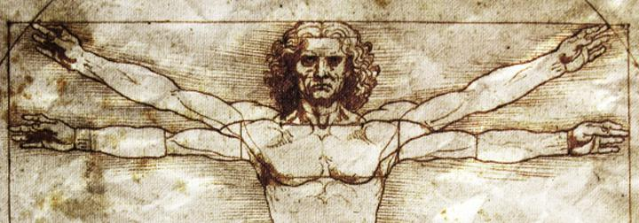

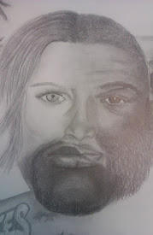
My Animation
My animation starts with the idea of identity. I feel that within art education it is important to help the kids understand and express how they identify with themselves. Within the animation different photos of how people can negatively or differently view themselves pop up, stressing the ideas of identity crisis, such as a person born into the wrong gender, as well as body image issues, such as anorexia. I then include pictures of different cultures and backgrounds, since your origin and the culture you live in has a huge influence over identity. The next point I bring up within the animation is world issues. I flash pictures of issues that occur around the world, such as starvation, war, the cruelty of animals, pollution, and litter. I then express in the animation that the best way to explore and express these issues within your own identity and even around the world, is through the use of creativity, which is another important part of art education.

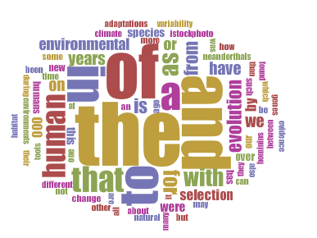
Technology within the Classroom

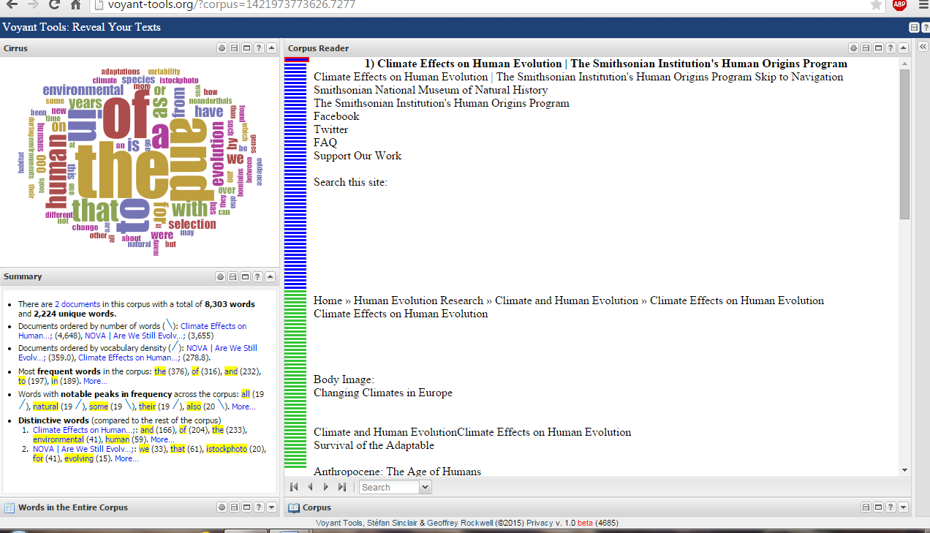

I chose Voyant Tools to compare the two articles; “Are We Still Evolving?” and “Climate Effects on Human Evolution.” Voyant Tools allows me to take these two articles on Anthropology and compare as well as determine the number of words included in the articles, the number of unique words, the length of the documents, and the vocabulary density. This in depth text analysis is all available on the convenience of my own laptop.

What I learned and how I plan on applying this to my future classroom:

In doing these projects I have discovered valuable information about myself as a future art educator. This assignment has made me consider many questions about why I decided to choose the path of art education as well as what key concepts I plan to bring into my future classroom. This project has also made me more comfortable with different technologies that I can introduce within the classroom, either as a tool to create art or as a resource to visually stimulate a concept.

Webquest
Objective:
-learn how to create an interactive lesson related to my teaching concept using technological mea ns
-present an example project related to my webquest
-explore and present a detailed explanation of technology that helped in the production of this project

Initial Webquest ideas:
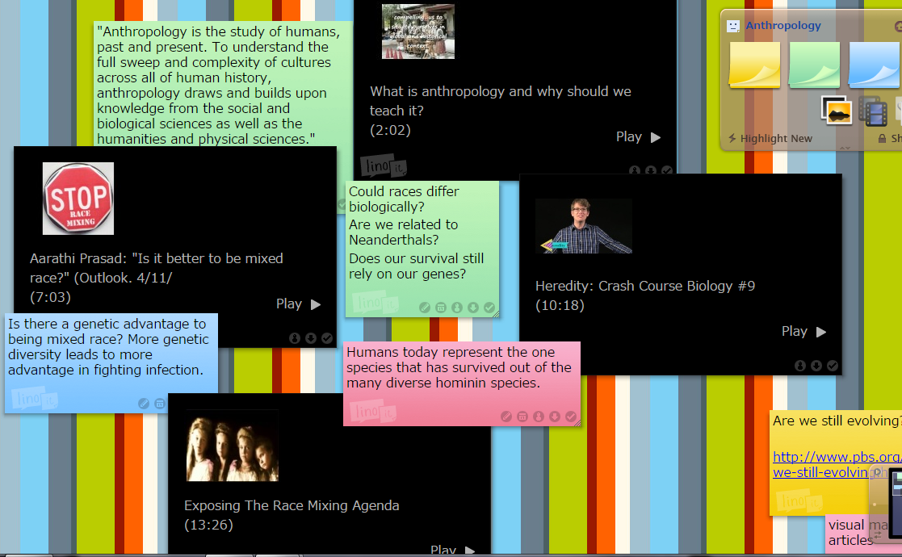

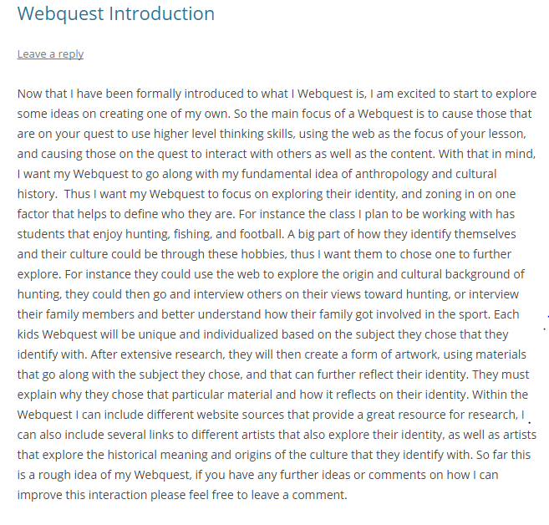

My Final Webquest:
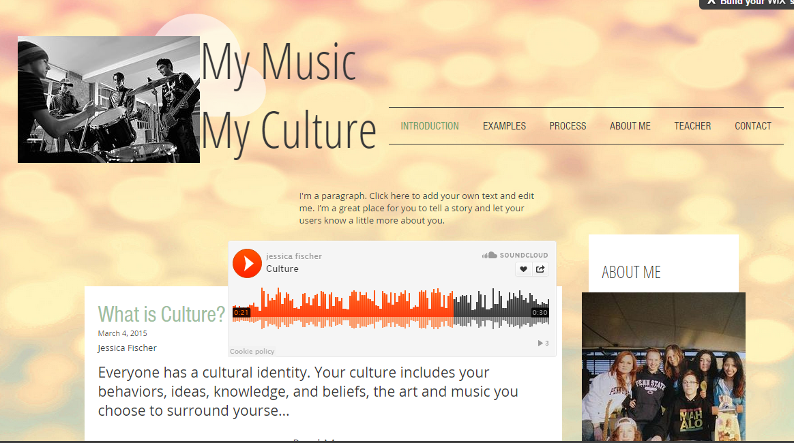
My Music, My Culture

This webquest is created to help the students better understand their culture and relate that to the amazing influence of music. I wanted students to use creativity and collaborate with one another to create a music video related to their cultural identity.
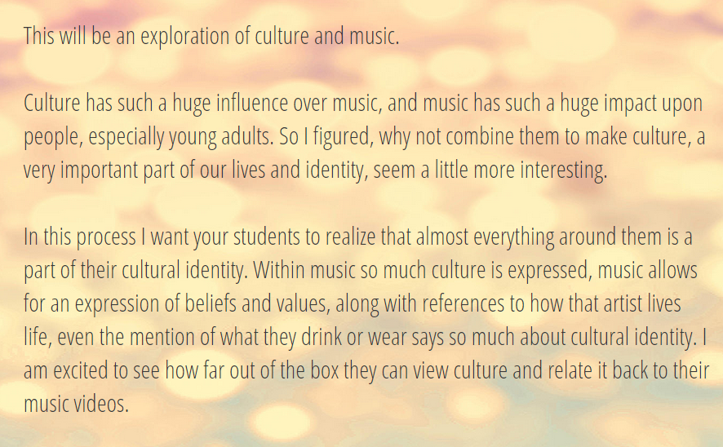
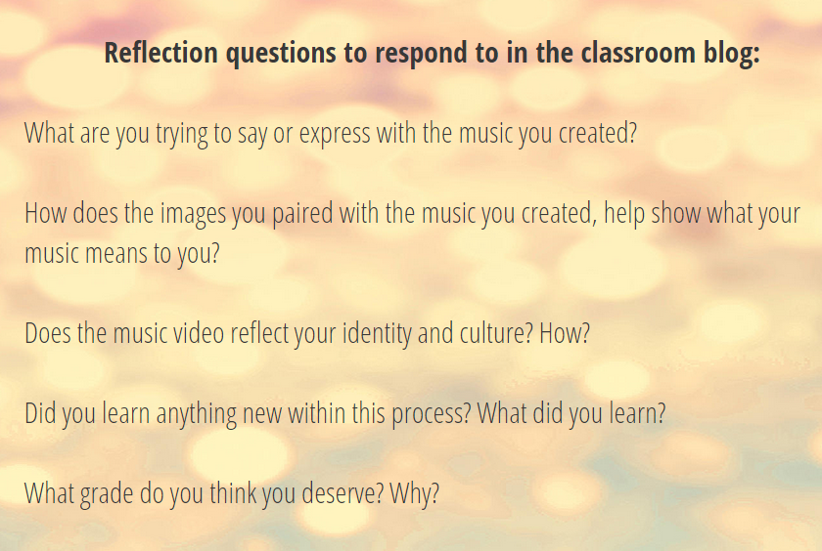
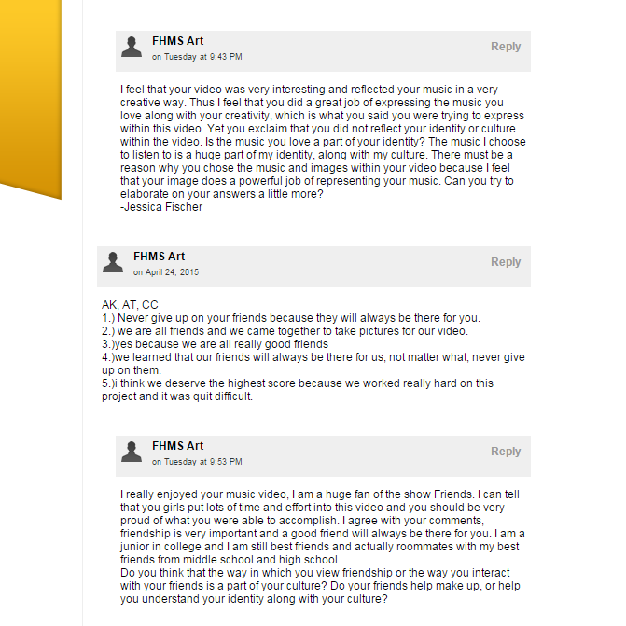
Student Blog
Student work
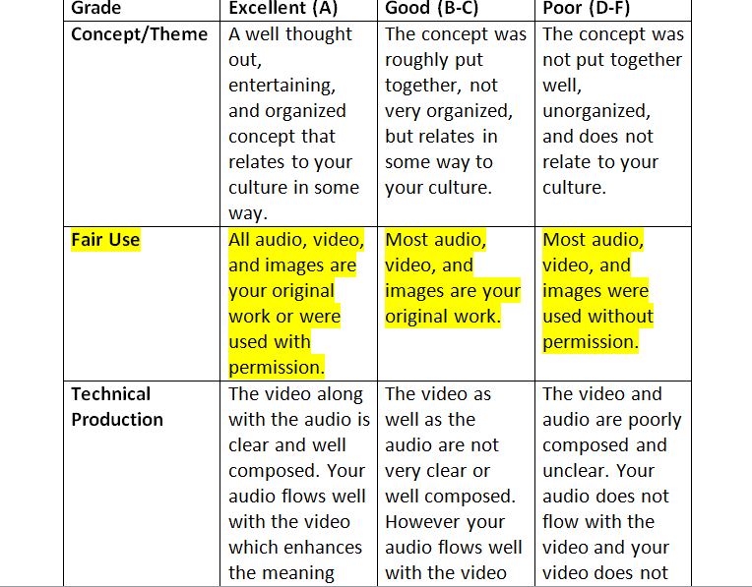
Grading Rubric

Grades
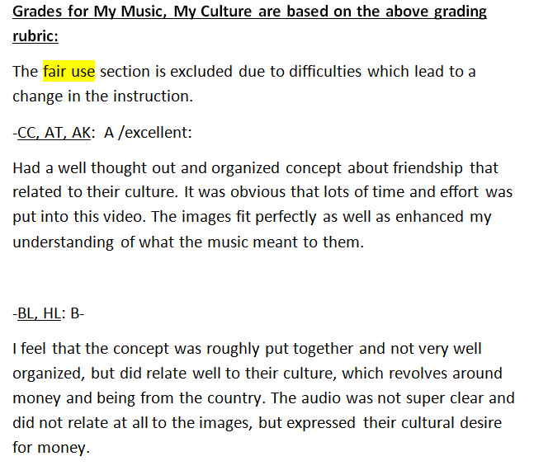

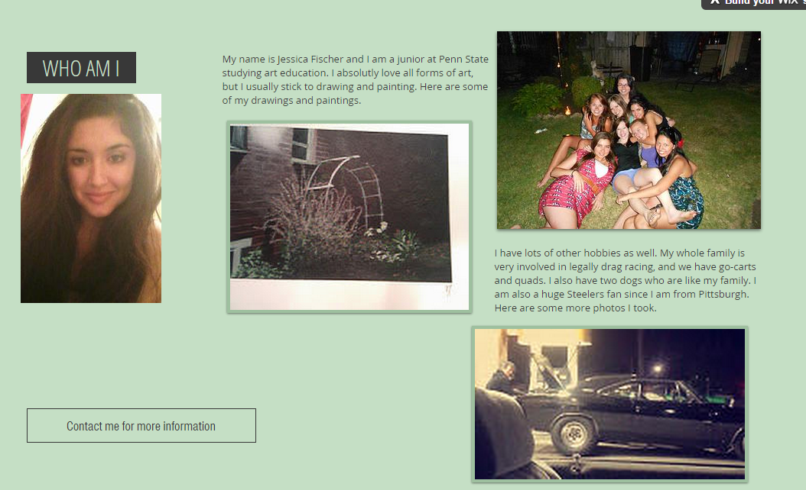
About Me
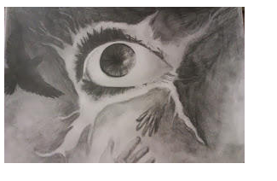
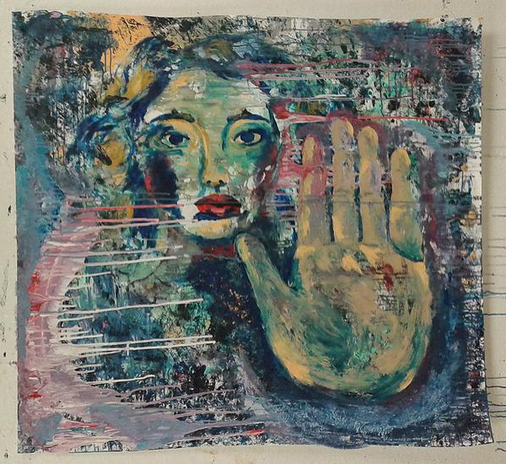
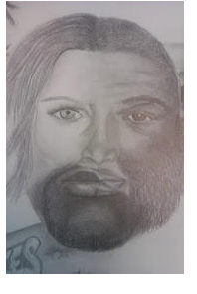

My Music Video
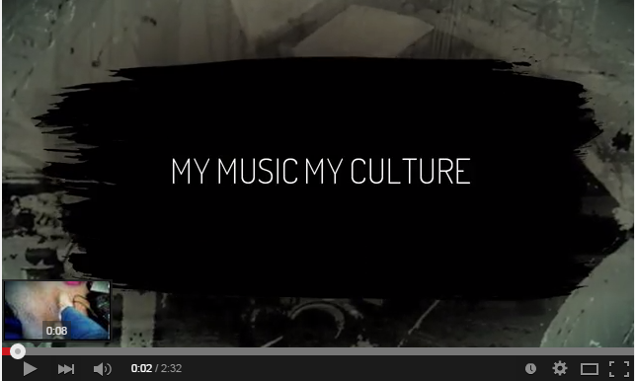
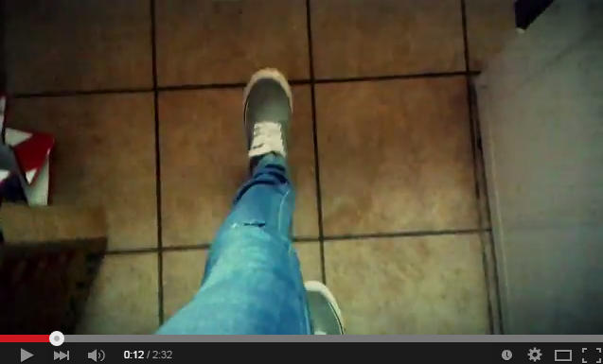
Reflecting on Technology
WeVideo
I have been exploring many different technologies that are new to me, such as Lino, Wix, Sound Cloud, Music Maker Jam, Garageband, Photoshop, This Penn State blogging site, and iMovie. All of these sites have played an important role in allowing me to feel comfortable exploring new technologies that I may be unfamiliar with. This new found comfort around technology is what caused me to discover one app in particular that I instantly fell in love with, WeVideo. This app inspires me to post on technology sites that I am more familiar with, such as Facebook and YouTube, sites that up until now, with the discovery of WeVideo, I never really had products that I wanted to upload. This is what the app WeVideo looks like.
I absolutely love this app because it is easy and fun to use right from your phone and the best part is it’s free! I am obsessed with this app because I have an Android; finding great, free, video apps is almost impossible to come by for those of us with Androids.
This app is so wonderful because all of your photos, videos, and music that are on your phone automatically transfer over to WeVideo. This is such a convenience, no extra time trying to download photos and music. This app is so quick and easy to use. This is what it looks like when you are inside the app.
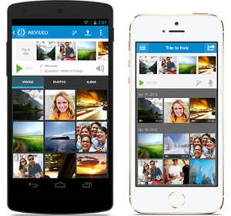
The above images are the images or videos you have chosen to include within your final video. The images under that are images or videos that you have taken with your phone. To put an image or video within your creation all you have to do is drag it into the placement you want it to be between, before, or after your other clips and photos. Once you have done this you have the option of clipping your video or increasing or decreasing the amount of time you want each photo to be up within the final video. To do this you simply click on the photo you want to change and go under the Trim tab, which can be seen below. So simple!
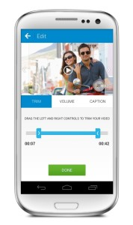
Within this app you also have the ability to add text onto each clip, yet again by simply clicking on the image you want to include text within and going under the Caption tab.
You also have complete control over the volume you want your full video, or individual clips to be. For instance if you use a video clip, you can turn the volume down, up, or completely off of the clip so that your other music throughout the whole video can be heard or the sound for that particular clip can be heard. To do this, yet again you simply click on the clip and go to the Volume tab.
As for the music, if you choose to have any throughout your video, you can also decide the volume control for that simply by clicking on the which is right on the main screen.
The music options for this app are wonderful, not only do you have access to all of the music on your phone, but the app also provides free music that goes along with each theme you can choose from to add to your video. This theme does not only provide free music, if you choose to use theirs, but it also adds a unique quality to your video as a whole. There are many themes to choose from, as seen in the image below.
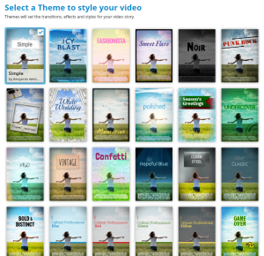 The themes include simple, icy blast, fashonista, sweet flare, and so on. The free music within each theme goes along perfectly with the theme, which i found pretty neat.
When it comes to music, the other great thing about this app is that it goes along great with other music making apps. For instance I used the music app Music Maker Jam, which I also highly recommend, and once i made a song on their, it was instantly under audio options within WeVideo without having to do a single thing. I was so impressed and relieved by this factor.
I absolutely love this app and cannot say enough how much I recommend its use. I already made two videos using this app, and am currently working on another one. My music video above is one of my videos I created using this app.
I think that this technology would be great to use within art education because it was such a fun and easy app for me to use. I know that video production, as confirmed by all of the YouTube videos as well as the kids obsession with making snapchat videos, is huge for kids nowadays and very intriguing to them. In sharing this app with students you would provide them with a great resource to produce videos.
The other wonderful aspect about this app is how easy it is to share your video with YouTube and Facebook all for free.
This app could also prove extremely valuable within art education when focusing on stop animation. Since this video allows the use of pictures from your phone, and offers how long you want each image to be viewed, i feel like it would be the perfect app for stop motion beginners.
Even in creating music videos, this would be the perfect app, since it allows you to bring in the music of your choice and it allows you to clip and add different videos together. This app is also great because it allows you to view your piece as often as you wish. You simply press the play button.
I would love to incorporate this app within my classroom, especially since now a days almost every kid past the age of 12 has a phone, and thus they hold the ability to create.

What I learned and how I plan on applying this to my future classroom:
In completing my webquest I experienced, for the first time, completing a detailed lesson plan. This was an incredibly useful task because this is something that I will need to do repeatedly in being an art educator. In doing this lesson through an online lesson, I learned how to use extreme detail and step by step planning. This activity also gave me the confidence and ability to create a website, which I never did before. I feel that using a webquest within my future classroom would prove very beneficial and could greatly help with my organization.
In creating a music video in correspondence to the activity I planned for my class to perform, I learned many valuable tools. In doing this task myself it proved to be of use, it made me realize the difficulty as well as different tools that could make the process easier. This process also helped me determine how to grade this assignment. I will definitely bring this experience into my future teaching, doing each assignment before having the students attempt the process. In doing this you also provide your students with a valuable example as well as pointers on how to go about the process.
In doing my music video I also found very valuable apps that could be used to help me more easily accomplish my desired goal. The app that proved the most useful was WeVideo. I think exploring new apps and technology in general, is so prized within education because it allows you to learn new resources and apply them to your lessons and pass on this learning to your students. This is most definitely an aspect I will bring into my future classroom.

Exhibition

Objective:

-create a work of art, using technology, related to racial issues within society

-curate a worldwide exhibit on racial ignorance through the means of technology

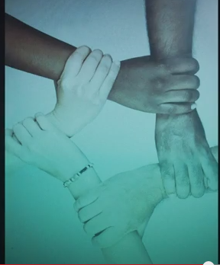

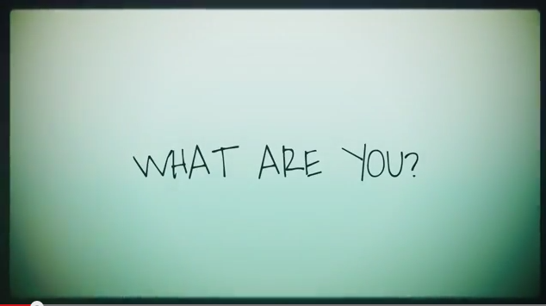
My Video
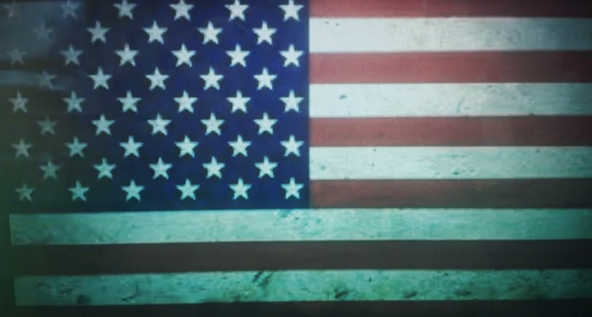

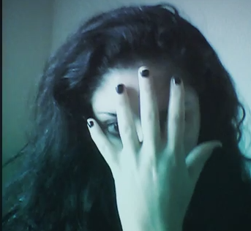

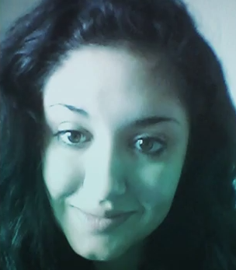
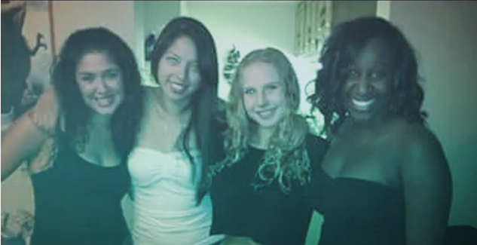

My Exhibition
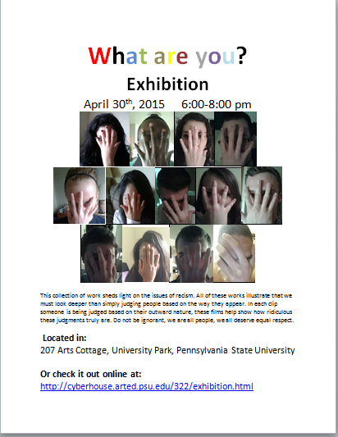
Full Exhibition

Curator Statement:
This collection of work sheds light on the issues of racism. All of these works illustrate that we must look deeper than simply judging people based on the way they appear. In each clip someone is being judged based on their outward nature, these films help show how ridiculous these judgments truly are. Do not be ignorant, we are all people, we all deserve equal respect.
Questions to consider when viewing these videos: Find cards:
1.) Find an aspect of this artwork that makes you feel angry? What was it that made you feel a type of anger? Why do you think it made you feel this way?
2.) Find something in these videos that made you feel proud? What made you feel a sense of pride? Why do you think you had this reaction?
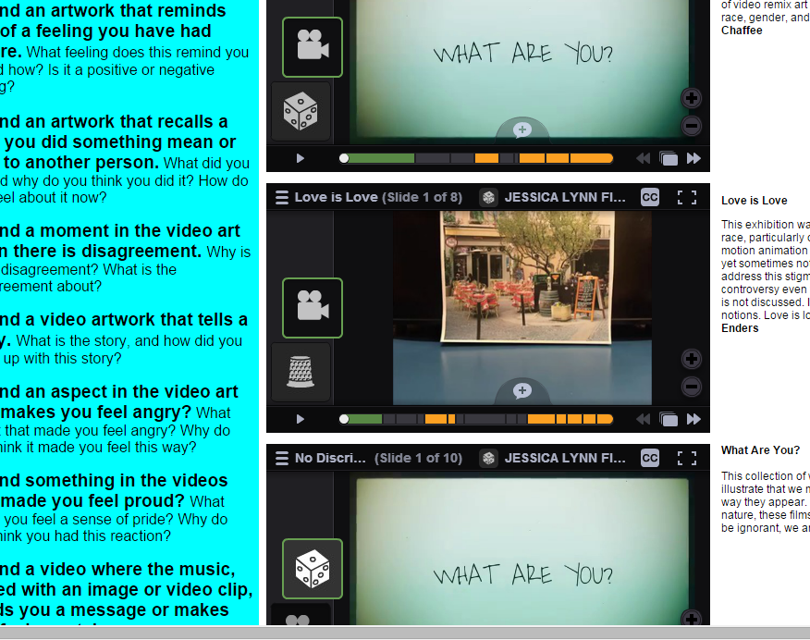
Our Exhibit:

What I learned and how I plan on applying this to my future classroom:
In creating my video on racial ignorance I learned how to further apply technology into creating a video that can shed light on certain issues. I plan on showing my future students that art is an amazing way to bring attention to problems within society or within themselves.
The exhibit was something I had never experienced before. In understanding how to show my work to such a wide audience, since it is in fact an online exhibition, my eyes were open to so many different possibilities of how I can get my work out there. This resource could also be used within a classroom to allow for a formal critique. In posting these projects online also gives a sense of pride to the creator, a sense of pride that I would love to share with my future students. I think that this could be a great resource to bring into my future classroom.

