**The Pennsylvania State University**



**SIMBA Hands-On Guide**

**ZFM_BUDGET_UPLOAD_FM Budget Upload Tool**



© 2020 The Pennsylvania State University  
© Copyright 2020 Labyrinth Solutions, Inc. All rights reserved. Labyrinth Solutions, Inc., the LSI logo, and CampusOneTM are trademarks of Labyrinth Consulting, Inc.   
SAP, R/3, SAP NetWeaver, and other SAP products and services mentioned herein as well as their respective logos are trademarks or registered trademarks of SAP AG in Germany and other countries.   
Business Objects and the Business Objects logo, BusinessObjects, Crystal Reports, Crystal Decisions, Web Intelligence, Xcelsius, and other Business Objects products and services mentioned herein as well as their respective logos are trademarks or registered trademarks of Business Objects S.A. in the United States and in other countries. Business Objects is an SAP company.

# ZFM_BUDGET_UPLOAD_FM Budget Upload Tool

## Overview

**Transaction Description:**

The tile is used to facilitate the entry of documents for budgeted funds.

**PSU Purpose:**

The transaction gives users the ability to upload a single budget adjustment or multiple budget documents.

## Process Steps

### Book2 - Excel

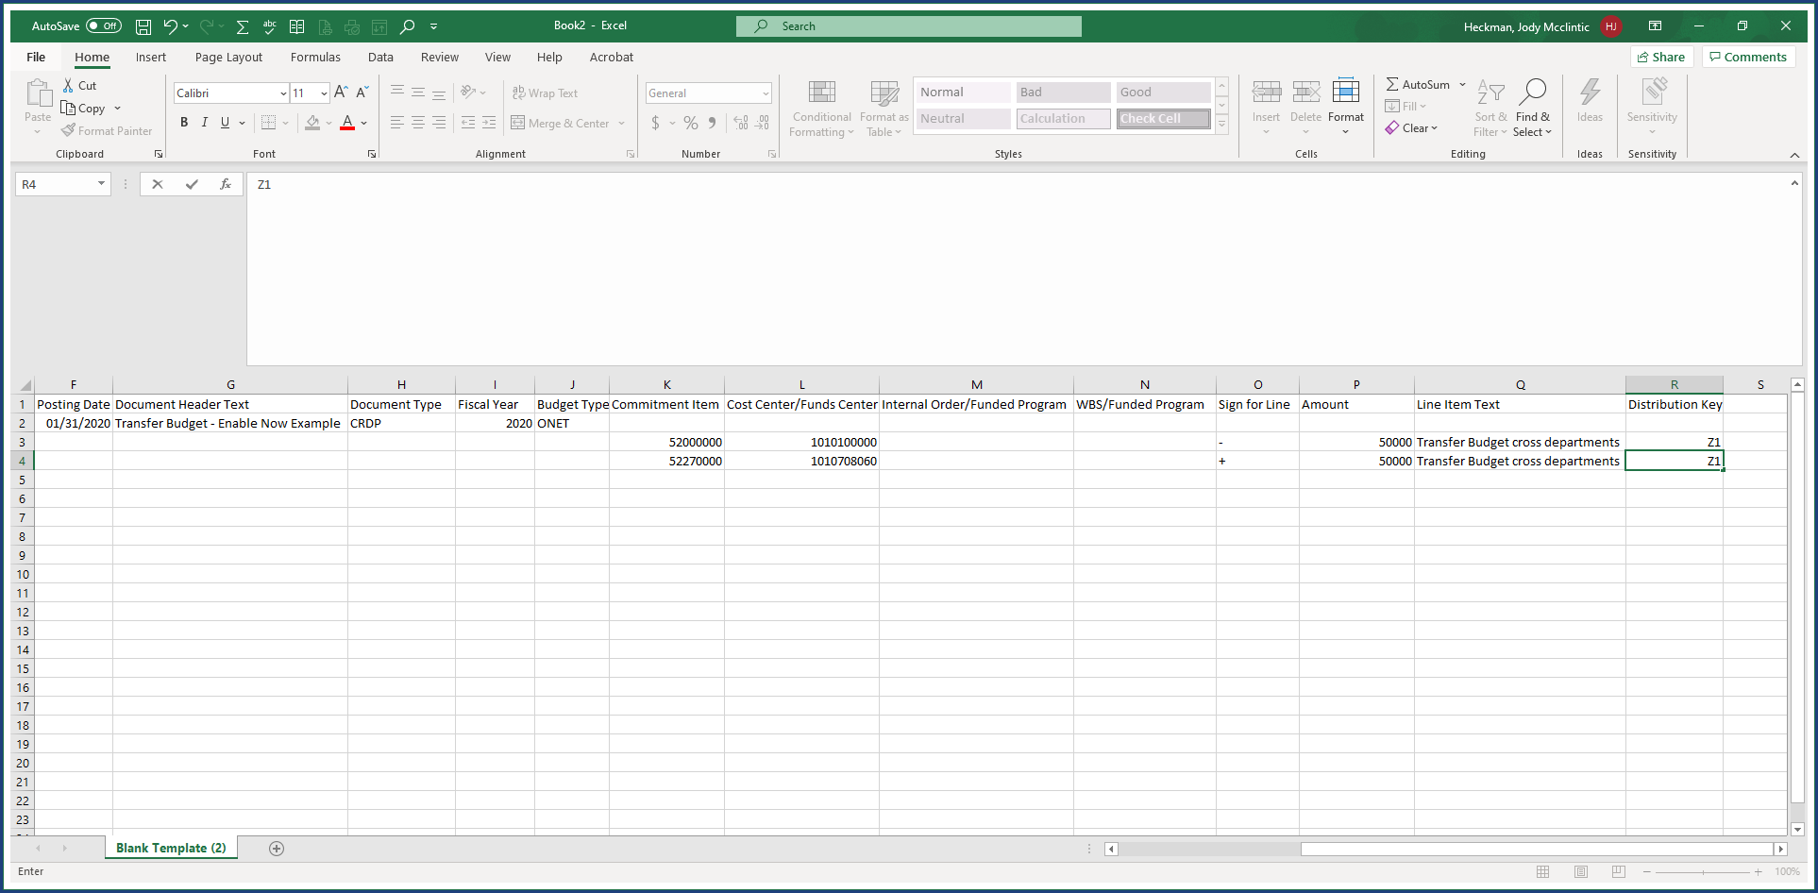

| Step | Action |
| --- | --- |
|  | An Excel Template is completed with budget transactions for upload.     * Templates can be found on the [SIMBA Templates & Tools](https://www.simba.psu.edu/support/templatesandtools/) page on the SIMBA website. * Use the Budget Upload Template for this transaction type. * Amounts must be numeric with no dollar signs, commas, or decimal for cents (cents will not be budgeted). * Each upload must be prepared as a single worksheet in an Excel workbook (no multiple tabs). * The completed Excel file is saved as a tab-delimited text file to the desktop. |

### FM Budget Upload

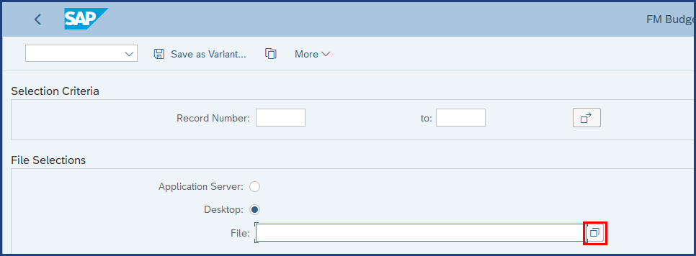

| Step | Action |
| --- | --- |
|  | Clicking the Possible Values button will open a dialog box and the file(s) to upload are selected from there. This part of the process is not shown here. |

### FM Budget Upload

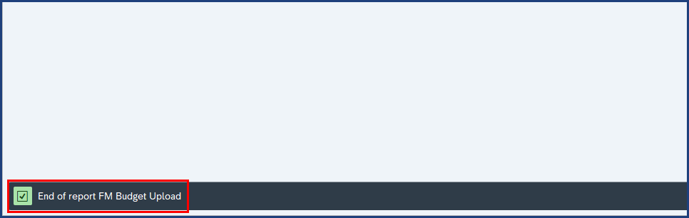

| Step | Action |
| --- | --- |
|  | System Status Bar Confirmation |

### FM Budget Upload

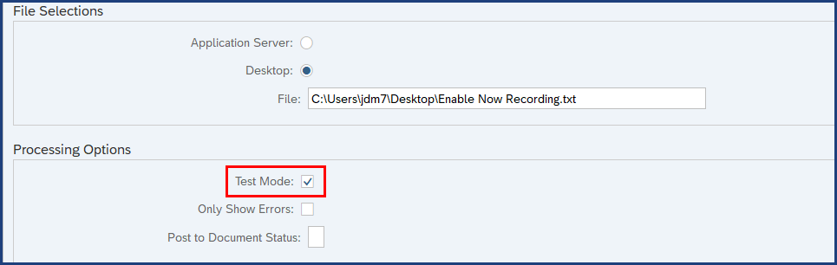

| Step | Action |
| --- | --- |
|  | Always run the transaction in Test Mode first. |

### FM Budget Upload

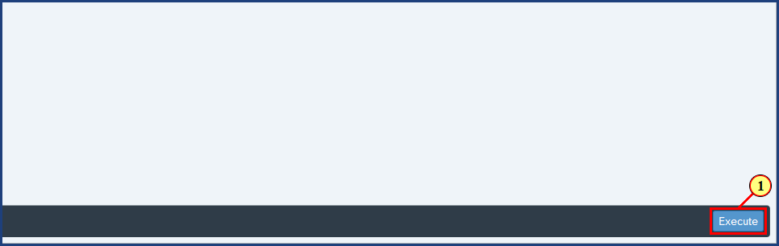

| Step | Action |
| --- | --- |
| 1. | The **Execute** button is clicked. |

### SAP GUI Security

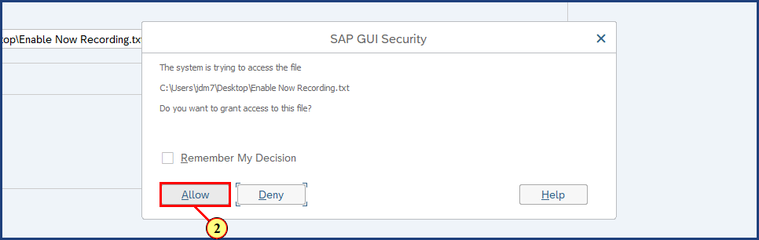

| Step | Action |
| --- | --- |
| 2. | The **Allow** button is clicked. |

### FM Budget Upload

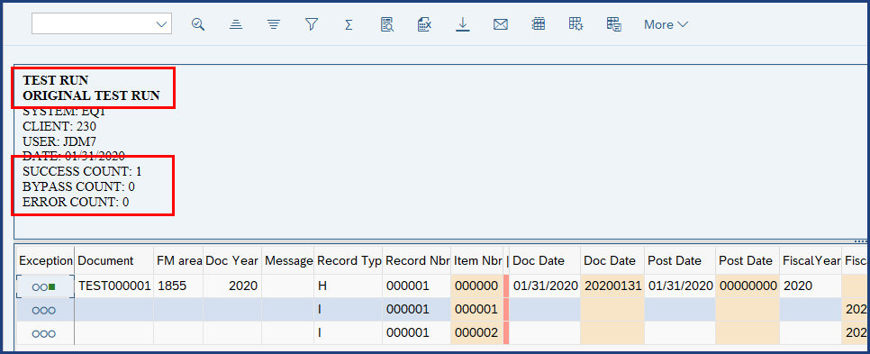

| Step | Action |
| --- | --- |
|  | The system confirms:   * We are running in Test mode * Success Count = 1 because there is only one header line. * Bypass Count = 0 * Error Count = 0     If there are any errors to correct:   1. Correct the errors in the Excel file 2. Save as tab-delimited text 3. Upload to the system for another Test Run |

### FM Budget Upload

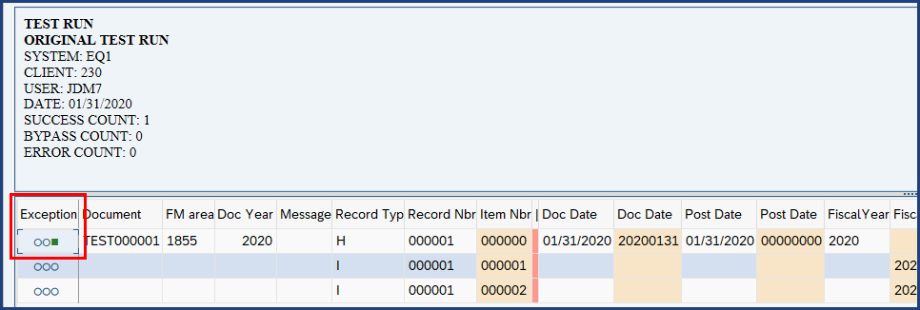

| Step | Action |
| --- | --- |
|  | Note: If successful, a green square icon will be displayed in the Exception column. |

### FM Budget Upload

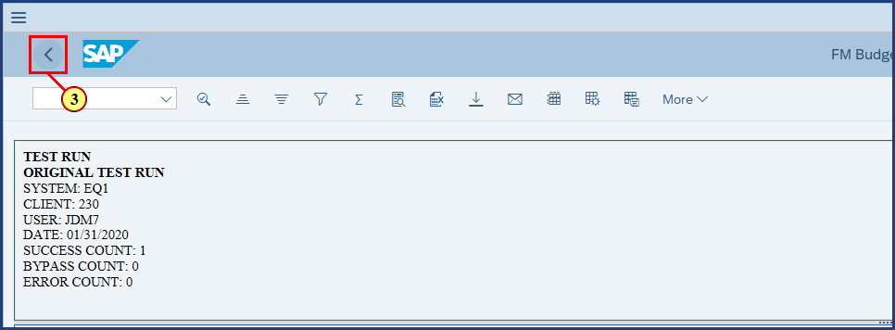

| Step | Action |
| --- | --- |
| 3. | The **Back** button is clicked. |

### FM Budget Upload

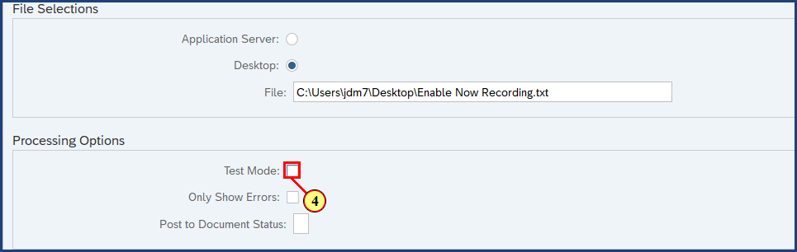

| Step | Action |
| --- | --- |
| 4. | The **Test Mode** check box is deselected. |

### FM Budget Upload

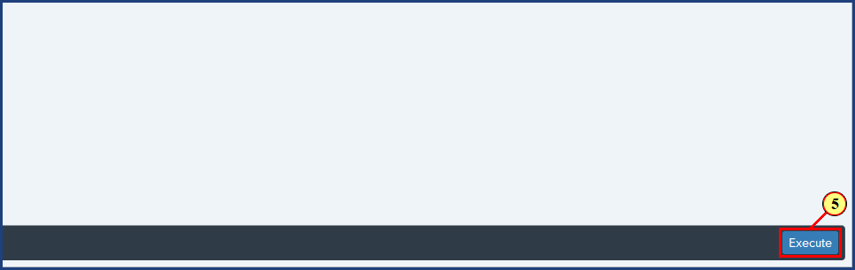

| Step | Action |
| --- | --- |
| 5. | The **Execute** button is clicked. |

### FM Budget Upload

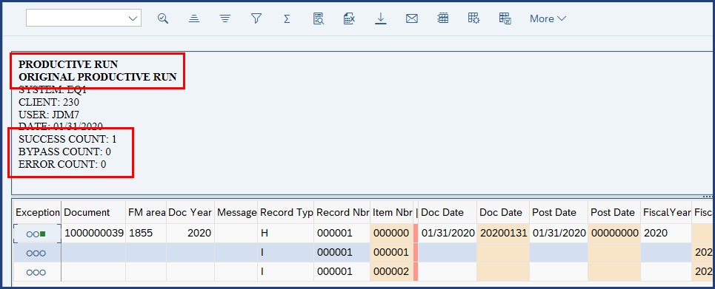

| Step | Action |
| --- | --- |
|  | The system confirms:   * We are running in Production mode * Success Count = 1 because there is only one header line. * Bypass Count = 0 * Error Count = 0     If there are any errors to correct:   1. Correct the errors in the Excel file 2. Save as tab-delimited text 3. Upload to the system for another Test Run |

### FM Budget Upload

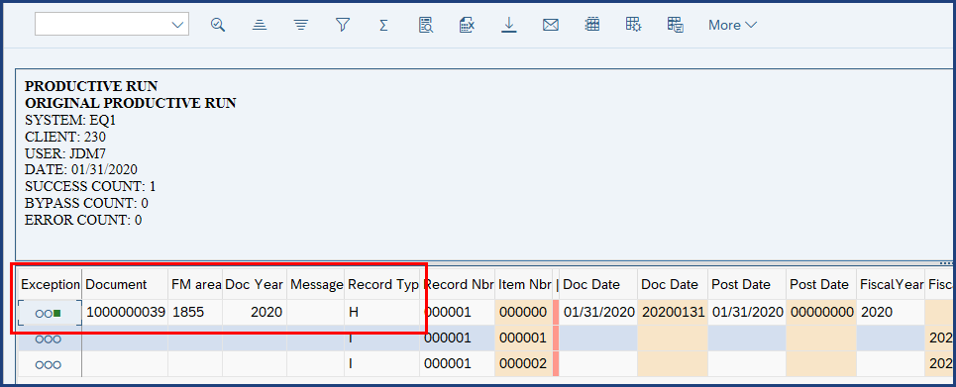

| Step | Action |
| --- | --- |
|  | Note: If successful, a green square icon will be displayed in the Exception column. Document numbers are displayed for each header document. |

**Disclaimer**

**Alternative Format Statement**   
This publication is available in alternative media upon request. 

**Statement of Non-Discrimination**

The University is committed to equal access to programs, facilities, admission, and employment for all persons. It is the policy of the University to maintain an environment free of harassment and free of discrimination against any person because of age, race, color, ancestry, national origin, religion, creed, service in uniformed services (as defined in state and federal law), veteran status, sex, sexual orientation, marital or family status, pregnancy, pregnancy-related conditions, physical or mental disability, gender, perceived gender, gender identity, genetic information, or political ideas. Discriminatory conduct and harassment, as well as sexual misconduct and relationship violence, violates the dignity of individuals, impedes the realization of the University’s educational mission, and will not be tolerated. Direct all inquiries regarding the nondiscrimination policy to Affirmative Action Office, The Pennsylvania State University, 328 Boucke Building, University Park, PA 16802-5901; Email: [aao@psu.edu](mailto:aao@psu.edu); Tel: 814-863-0471.