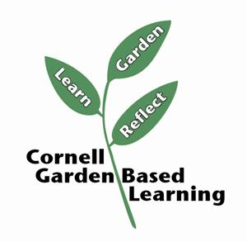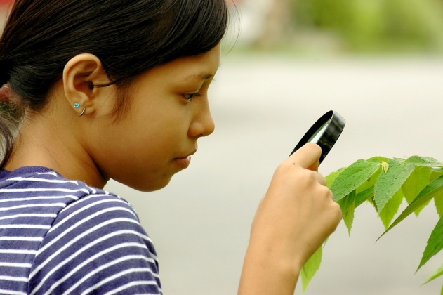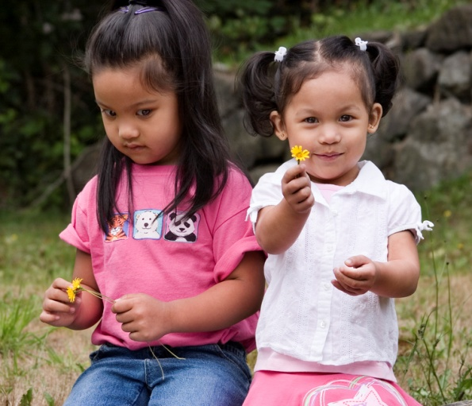

gardening.cornell.edu

*Please insert some information about your organization here, e.g. a slogan or general introduction about your purpose*

### Upcoming Workshops, Meetings, and Programs:

**Date 1**

Meeting at …

**Date 2**

Workshop on …

## Contact Information

**Email:**  *insert a web address*

**Phone:**  xxx – xxx – xxx

**Mailing Address:**

Address line 1

Address line 2

Address line 3

*Follow us on Twitter and Facebook, if applicable*

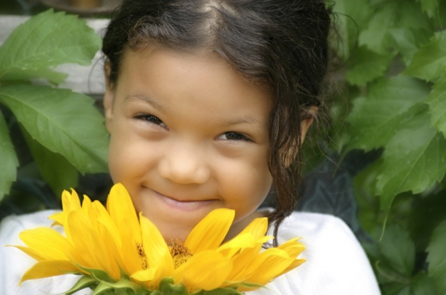

### Our Mission

### ***Insert a short paragraph about your organization here – this statement should be concise and easy to understand.***

### Our Work

*Please insert a few paragraph regarding the work of your organization. This can include any or all of the following suggestions:*

* *Information regarding your objectives*
* *Overview of ongoing and past projects*
* *Profiles of some of the people involved in your group*
* *Your methods to achieve your goals*
* *Accomplishments / goals reached*
* *What separates your group from alternatives? Why are you special?*
* *Interesting facts and statistics*

We thank our partners for their continued support:



## What is Garden-based Learning?

Garden-based learning programs result in increased nutrition and environmental awareness, higher learning achievements, and increased life skills for our students. They are an effective and engaging way to integrate curriculum and meet learning standards, giving young people the chance to develop a wide range of academic and social skills.

Garden experiences foster ecological consciousness by providing time and space to explore the natural world. This hands-on work also promotes community values, such as friendship, cooperation, and communication.

Garden-based learning results in healthy young minds and bodies, and provides a unique tool to engage student interest both inside and outside of the classroom. At its core, garden-based learning strives to create a strong foundation for integrated learning and youth development.





[**gardening.cornell.edu**](http://www.hort.cornell.edu/gbl)